Linux command

Creat a link

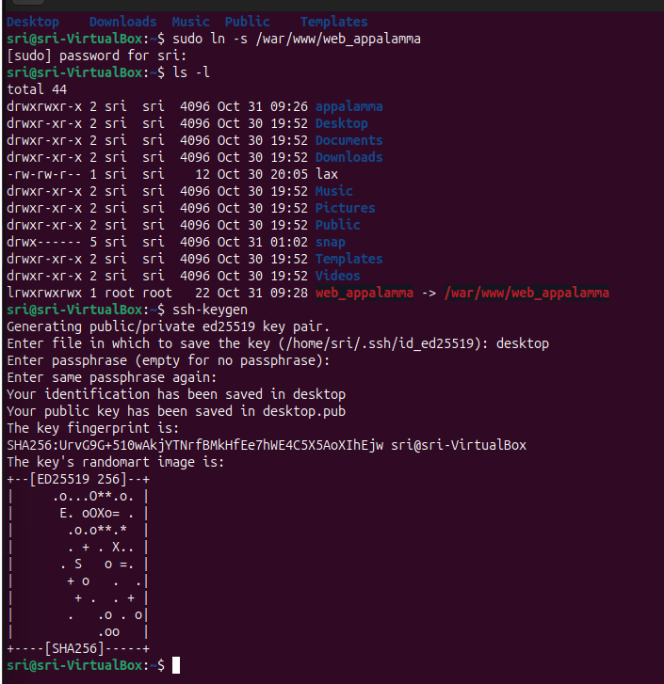

Git install 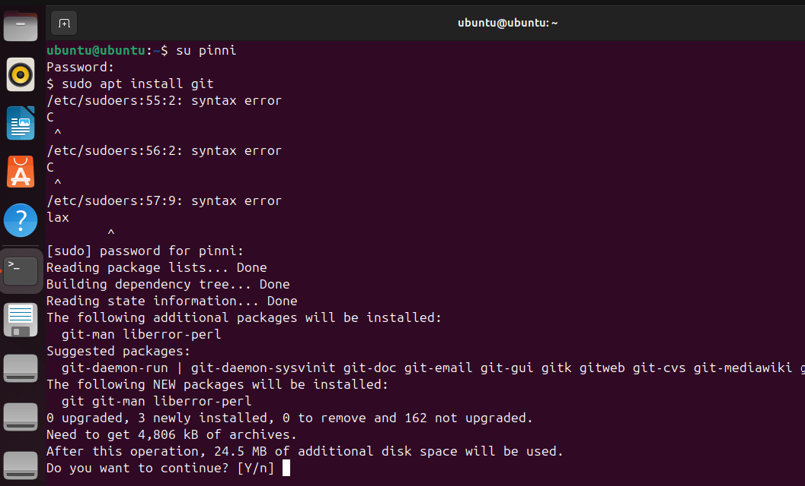
Check the sudoers
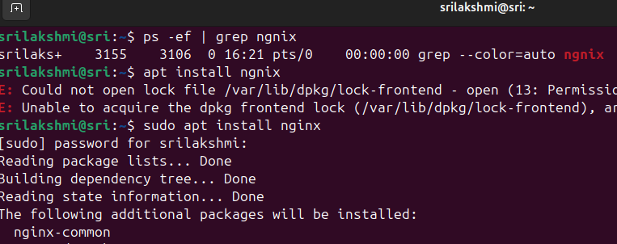
Check the running port numbers
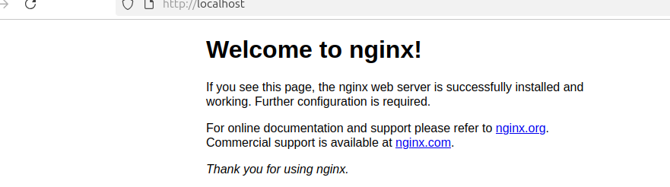
After the process services the localhost

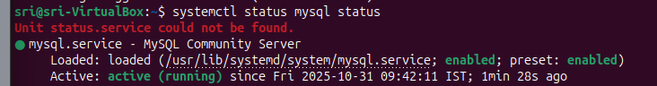
Status of mysql
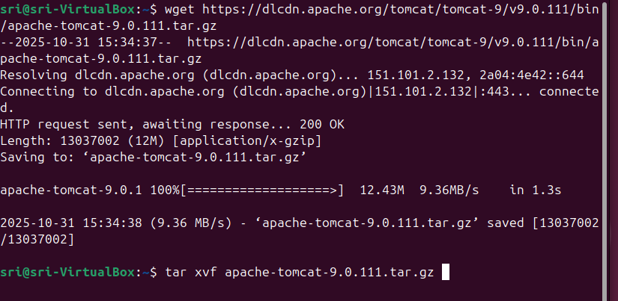

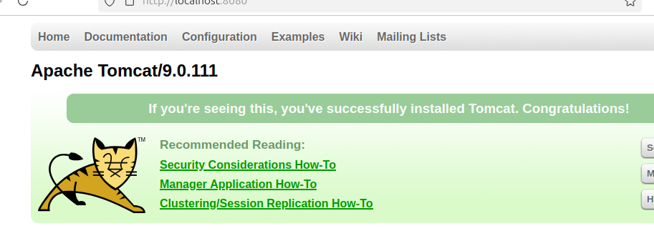
Setup the application server

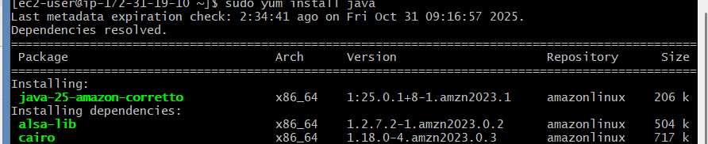
Java install
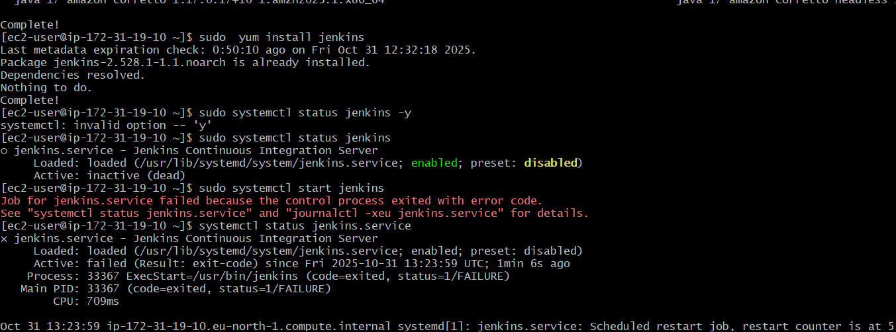
Install the Jenkins
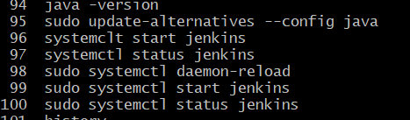
Check the java versions

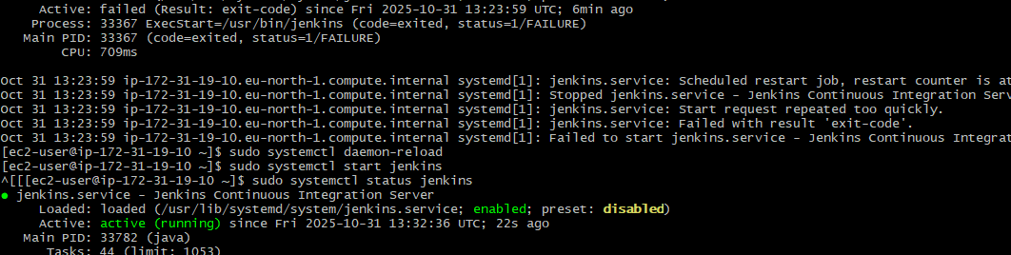
Check the status of service

Check the status of apache 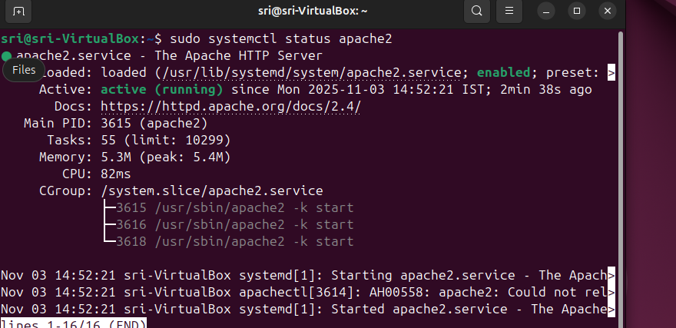
+6*5/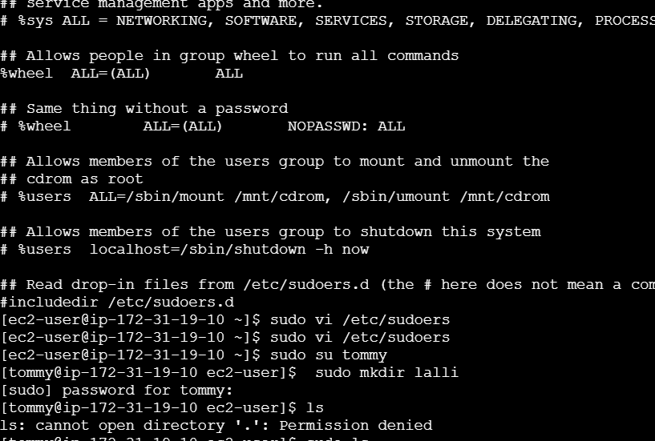
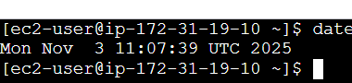
To check the date
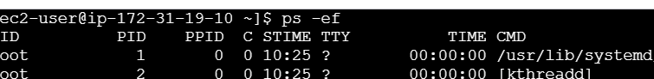
To check the runcing process ( ps -ef )
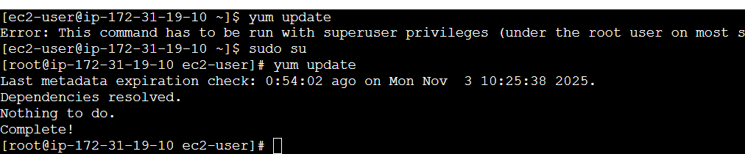
Updates servers
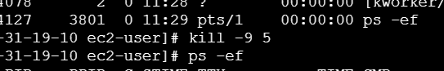
Kill -9 is used to kill the process
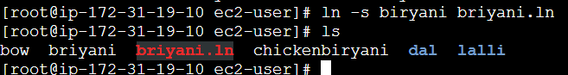
To create the soft link
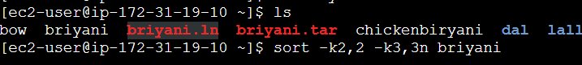
Sort the file
Merge files
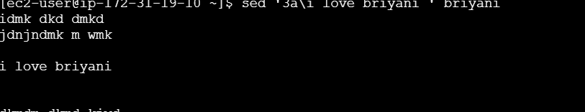
Append insert the text before /after
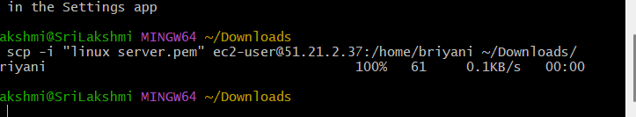
Copy file form linux to windows

